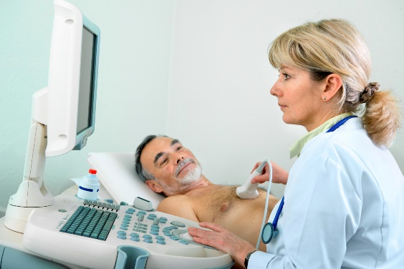
Firefighters Health Plan Cancer / Cardio Screening
TO: Local 22 Health Plan Members / Spouses
FROM: Local 22 Health Plan
RE: Ultrasound Screening Event
DATE: June 3rd - June 7th

The Firefighters & Paramedics Local 22 Health Plan will be hosting a Free Ultrasound Screening Monday June 3rd through June 7th. This event will be taking place at 415 N 5th street - Philadelphia, Pa 19123
Why should you participate in the Ultrasound Screening?
- First, early detection of any cardiovascular issues is crucial for preventing a serious health crisis. Unfortunately, doctors are usually unable to prescribe diagnostic tests without symptoms. A Vascular screen tests for plaque build-up on the artery walls, blockages or restrictions in blood flow and indicates signs of potential strokes, heart attacks or aneurysms.
- Second, our health screen partner, National Diagnostic Services, is a mobile screening company, that is a certified cardiovascular lab. They are also the only provider from whom you’ll receive a comprehensive evaluation of the major abdominal organs to detect serious illnesses such as Cancers and Tumors.
All tests are Ultrasound based & therefore are PAINLESS, and NON-INVASIVE.
Package 1: Includes Thyroid, Testicular (men), General Pelvic (women), and Bladder
Package 2: Includes Carotid, Ankle Brachial Index (ABI), Abdominal Aortic
Aneurysm (AAA), Thyroid and Bladder Ultrasounds.
Local 22 is dedicated to the Health & Wellness of our members!
Pre-registration is required. To schedule your appointment:
- Go to: https://ndsscheduling.liveeditaurora.com/
- Select “create an account”
- Complete the requested fields
- Click “Submit”
- Under “Choose your location”
Select: “Philadelphia Local 22”
- Under “Choose Your Type of Appointment”
Select: “Ultrasound Screening”
- Click “Search”
- Select your desired appointment date/time
Please note: your room number does not matter! Pick either 1 or 2.
- Click “Book”
- A blue dialog Click “Book Appointment”
- You will get a welcome email and appointment confirmation email with exam instructions.
For questions please call (248) 476-6980

