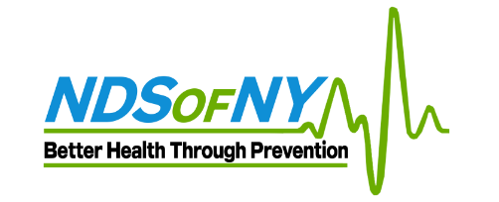

Local 22 HEALTH PLAN Medical Ultrasound Screening

TO: ACTIVE and RETIREE MEMBERS of Local 22 Health Plan
FROM: Jerry Kots
RE: Medical Ultrasound Screening Event
DATE: April 18th through April 29th, 2022
As a result of our continued commitment to the Health and Wellness of our members, Local 22 Health Plan is hosting an Ultrasound Screening Mondays to Fridays starting Monday, April 18th through Friday, April 29th, 2022. This event will take place at Local 22, 415 N.5th Street, Philadelphia, PA, 19123-4095.
Why should you participate in the Heart-Vascular and Cancer Ultrasound Screening?
First, early detection of any cardiovascular issues is crucial for preventing a serious health crisis. Unfortunately, doctors are usually unable to prescribe diagnostic tests without symptoms. A Heart and Vascular screen tests for plaque build-up on the artery walls, blockages or restrictions in blood flow and indicates signs of potential strokes, heart attacks or aneurysms.
Second, our health screen partner, National Diagnostic Services, is the only mobile screening company in the nation that is a certified cardiovascular lab. They are also the only provider from whom you will receive a comprehensive evaluation of the major abdominal organs to detect serious illnesses such as cancers, tumors and blood clots.
All tests are ultrasound based and therefore painless, and non-invasive. Tests include an Echocardiogram, Carotid, Abdominal Aorta, Thyroid, Liver, Spleen, Bladder, Kidney, and Testicular. This screen also includes an Exterior Pelvic scan for females. The examination will take approximately 30 min to complete.
Pre-registration is required. To schedule your appointment:
- Go to: https://ndsscheduling.liveeditaurora.com/
- Select “create an account”
- Complete the requested fields
- Click “Submit”
- Under “Choose your location” select: “IAFF Local 22”
- Under “Choose Your Type of Appointment” select: “Ultrasound Screening”
- Click “Search”
- Select your desired appointment date/time (note: room number does not matter! Pick either 1 or 2)
- Click “Book”
- A blue dialog will appear, Click “Book Appointment”
- You will get a welcome email and appointment confirmation email with exam instructions

For questions please call Stephanie Savage (516) 450-7255

